Group Banquet Picture 2016

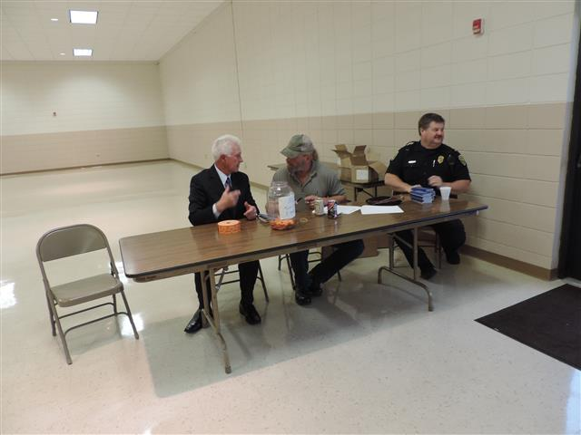

Boardman's Officer McDonnell Makes Sure That Ljubo and Mike Hand Out the Calender Books Fairly!

Award Recipients for 2016

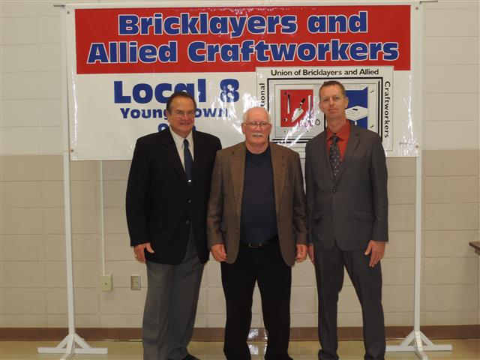

President Kurtz, -
25 Year Recipients: Frank Porter, Eric Patterson, Richard Hidasy - Field Rep. Brian Collier

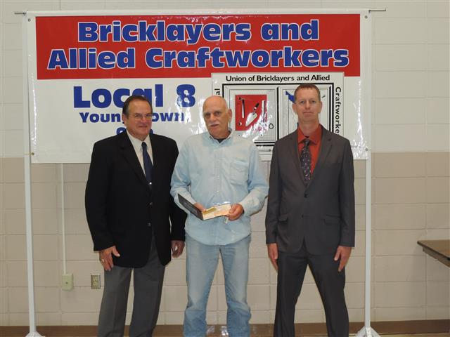

President Kurtz - Fifty Year Recipient: Roger Mincks - Field Representative Brian Collier

